Abstract 1

Introduction to Natural Language Processing 1

History and Development of NLP 1

Key Concepts in NLP 2

Tokenization 2

Part-of-Speech Tagging 3

Named Entity Recognition 4

Sentimental Analysis 5

Stemming and Lemmatization 6

Stop Words 6

Applications of NLP 7

Machine Translation 7

Chatbots and Virtual Assistants 7

Text Summarization 8

Email Filtering 8

Challenges and Future Directions in NLP 9

Conclusion 9

References 10

# **Abstract**

This paper provides an overview of Natural Language Processing. It provides a quick introduction and history, as well as key concepts such as tokenization, sentimental analysis and much more. It then goes into applications of natural language processing in chatbots and machine translation. Finally, it covers the limitations of natural language processing, current and future.

# **Introduction to Natural Language Processing**

Natural language processing is a branch of artificial intelligence and machine learning that deals with the computer’s ability to interpret human language and generate human-like text. This is such a significant field because human language is intricate and diverse. Natural language processing intends to overcome these obstacles by enabling computers to process language like us.

# **History and Development of NLP**

The field of Natural Language Processing (NLP) began in the 1940s after World War II with the goal of automating language translation.NLP development was driven by the need for efficient information processing and communication. The war highlighted the importance of codebreaking, intelligence analysis, and rapid translation. These tasks were time-consuming and prone to human error. However, researchers soon encountered significant challenges. Noam Chomsky identified one such issue: models often classified grammatically correct but nonsensical sentences as equally irrelevant as grammatically incorrect ones. Chomsky argued that this was problematic, as humans can easily distinguish between the two.

# **Key Concepts in NLP**

## **Tokenization**

Tokenization in NLP breaks down the text into smaller units, called tokens, to make it easier for machines to process. Tokenization is the start of the NLP process, converting text into understandable bits for the machine to interpret, without tokenization the NLP will not be able to interpret most of what you are trying to say.

One example of tokenization provided by [geeksforgeeks.org](https://www.geeksforgeeks.org/nlp-how-tokenizing-text-sentence-words-works/) is:

Input: "Tokenization is an important NLP task. It helps break down text into smaller units."  
Output: ["Tokenization is an important NLP task.", "It helps break down text into smaller units."]

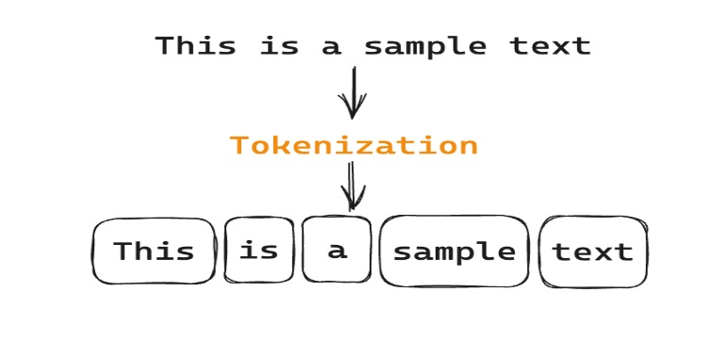

Tokenization will break down the context to make it easier for the NLP machine to understand.

There are some downsides to tokenization which are (OOV) Out- of- vocabulary words which “can have multiple meanings, and context is needed for accurate segmentation.” [SoluLab](https://www.solulab.com/tokenization-nlp/#:~:text=Tokenization%20faces%20challenges%20such%20as,present%20in%20the%20model's%20vocabulary.)

## **Part-of-Speech Tagging**

Parts of speech (POS) tagging, a main task of NLP, assigns grammatical labels to words in text (e.g., noun, verb, adjective). This is crucial for NLP tasks like machine translation, as it helps identify word roles and meanings within sentences. These tags aid computers in comprehending a sentence's syntactic structure and the semantic function of individual words.

* They are grammatical categories assigned to words in a text to indicate their part of speech.
* A key step in natural language processing and is based on word’s definition and context and is useful for machine translation.
* Entails the understanding of each word’s purpose inside the sentence including whether word is an adjective, verb, and noun.

**Example: Simple Sentence**

Sentence: "The cat sleeps."

**Explanation:**

**The** is a determiner that specifies the noun.

**cat** is a noun, the subject of the sentence.

**sleeps** is a verb indicating the action.

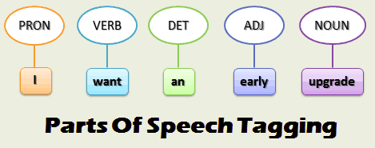

## **Named Entity Recognition**

* Technique that identifies and classifies vital information in text.
* Can identify and categorize key pieces of information in instructed text.
* Categorizes key elements within text such as location, person, product, and date.
* **Example:** Elon Musk **(Person)** drove his Tesla **(Product)** to Georgia **(Location)** on August 23rd (**Date**).

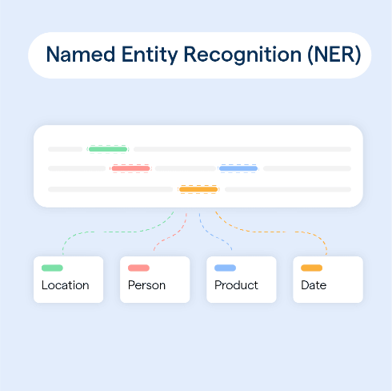

## **Sentimental Analysis**

Sentimental Analysis is a computer’s ability to determine tone of a text whether it be **positive, neutral, or negative**. This is important because a computer must determine the appropriate response to a text when the tone is negative, positive, or neutral – determining if a review is positive or negative or adapting tone in response from chatbots.

**Examples:**

*“The service at this place was dreadful and the entrees were overpriced!”*

* This sentence would classify as **negative**. Words like ‘dreadful’ and ‘overpriced’ would cues that help a computer categorize this as having a negative sentiment.

*“The service at this place was decent and the food met expectations, but price could be changed.”*

* This sentence would classify as **neutral.** The positive comments about decent setting and food meeting expectations are balanced by a small negative comment about price would deem it neutral because the writer is not taking a full positive or negative sentiment.

*“The service at this place was impeccable, the food was great and worth the wait!”*

* This sentence would classify as **positive**. Words like ‘impeccable’ and ‘great’ would cue a computer into categorizing this as a positive statement.

## **Stemming and Lemmatization**

Stemming and lemmatization is when a computer reduces a word to its base form. Stemming and lemmatization are quite similar, however there are differences.

**Stemming** is when the affixes of word are removed to reduce it to its base form.

Example: “Running” turns into “run.” The “-ing” was removed from the original word

**Lemmatization** is reducing a word to its base form/dictionary form

Example: “Worse” turns into “bad.” Since worse is the same bad, the general dictionary form, it is converted to it.

## **Stop Words**

To improve the accuracy and efficiency of NLP, it is helpful to remove simple words that do not add much to the text. These words, often called stop words, include “a”,” of”,” on,” “the.” By filtering them out, we can focus on the more important words and get better results from NLP tasks like analyzing feelings, categorizing text, and finding information.

* An example of a sentence with and without stop words:

**Original Sentence:** "The quick brown fox jumps over the lazy dog."

**Without Stop Words:** "quick brown fox jumps lazy dog"

As you can see here, removing stop words can simplify the text without losing its core meaning.

# **Applications of NLP**

Applications of NLP have many different services such as spell checkers, online search, translators, voice assistants, spam filters, and auto correct.

## **Machine Translation**

This is the translation of text or speech from one language to another. Translation services used to ignore the fact that many languages have different sentence structures and cannot be translated directly. However, they have made great progress. Online translators can now accurately translate languages and display grammatically correct results thanks to NLP technology, which improves the accuracy and efficiency of communication. Input text can now be recognized and translated by tools, improving communication across languages.

**Examples:** Google translate, Microsoft translate, DeepL Translator, and Linguee

## **Chatbots and Virtual Assistants**

Chatbots and virtual assistants are a significant application of NLP. They are AI programs designed to interact with humans in a way that simulates human conversation. These conversational AI systems can provide numerous services, such as customer support, information retrieval, and even companionship. They can be used in various industries, including e-commerce, healthcare, and education. As NLP technology continues to advance, we can expect chatbots and virtual assistants to become even more sophisticated and capable of handling more complex interactions.  
**Examples:** customer service chatbot, healthcare chatbot, Siri, Alexa, and Google assistant

## **Text Summarization**

This is an NLP approach that automatically reduces lengthy texts into brief summaries. When you are short on time or need to rapidly understand the key points of a long paper, this can be helpful.

**How does it work?**

1. The text undergoes preprocessing, which involves tokenization, stemming, and removing stop words.
2. Key features like keywords and sentence length are extracted.
3. A summarization algorithm is applied to select relevant sentences using techniques like extractive or abstractive summarization.

## **Email Filtering**

One popular use of natural language processing (NLP) is email filtering, which aids in controlling the overwhelming amount of emails we get every day. NLP algorithms can automatically classify and arrange emails into designated categories or labels by examining their content.

**Example:** Gmail uses NLP to provide:

* **Smart Labels:** Automatically categorize emails into specific labels, such as "Promotions," "Social," and "Primary."
* **Smart Replies:** Suggest quick, context-aware replies to emails.
* **Priority Inbox:** Prioritize important emails based on their content and sender.

# **Challenges and Future Directions in NLP**

**Current Challenges:**

* **Contextual Ambiguity:** Natural language is inherently ambiguous, and understanding context is crucial for accurate interpretation.
* **Data Quality and Bias:** The quality and diversity of training data can significantly impact model performance, and biases present in the data can be reflected in the model's outputs.
* **Resource Demands:** NLP models often require substantial computational resources for training and inference, limiting their accessibility in certain applications.

**Future Directions:**

* **Contextual Understanding:** Developing models that can better grasp the context of a sentence or conversation.
* **Explainable AI:** Making NLP models more transparent and interpretable, so that users can comprehend how they arrive at their conclusions.
* **Ethical Considerations:** Ensuring that NLP models are developed and used ethically, avoiding biases and harmful outcomes.

# **Conclusion**

Natural language processing is significant in the world of artificial intelligence and will continue to grow alongside it. With natural language processing already having so many applications, it is not too soon until it fully integrates itself into other fields like healthcare. Despite the challenges of resource demands and the ambiguous nature of human language, new advancements can help overcome these obstacles.

# **References**

“NLP - Overview.” *Cs.stanford.edu*, <https://cs.stanford.edu/people/eroberts/courses/soco/projects/2004-05/nlp/overview_history.html>

Jurafsky, D., & Martin, J. H. (2024). Speech and Language Processing: An Introduction to Natural Language Processing, Computational Linguistics, and Speech Recognition with Language Models (3rd ed.). Online manuscript released August 20, 2024. <http://www.web.stanford.edu/~jurafsky/slp3/ed3book.pdf>

Ganesan, Kavita. “What Are Stop Words?” *Opinosis Analytics*, 6 Apr. 2019, [www.opinosis-analytics.com/knowledge-base/stop-words-explained/](https://www.opinosis-analytics.com/knowledge-base/stop-words-explained/).

**Amazon Web Services.** (n.d.). *Sentiment Analysis.* Retrieved from [What is Sentiment Analysis? - Sentiment Analysis Explained - AWS](https://aws.amazon.com/what-is/sentiment-analysis/#:~:text=Sentiment%20analysis%20is%20an%20application,before%20providing%20the%20final%20result.)

**SoluLab** | Blockchain Development Company

[https://www.solulab.com/tokenization](https://www.solulab.com/tokenization-nlp/#:~:text=Tokenization%20faces%20challenges%20such%20as,present%20in%20the%20model's%20vocabulary.)

Dutta, Bhumika. “Top 10 Applications for Natural Language Processing (NLP) | Analytics Steps.” *Www.analyticssteps.com*, [www.analyticssteps.com/blogs/top-10-applications-natural-language-processing-nlp](https://www.analyticssteps.com/blogs/top-10-applications-natural-language-processing-nlp).